**Module 6) JAVASCRIPT BASIC & DOM**

**Q.1 What is JavaScript. How to use it?**

**Ans:-**

* JavaScript is a high-level, interpreted programming language that is commonly used to make web pages interactive.
* It's a versatile language that can be used both on the client side and on the server side.
* JavaScript used alongside HTML and CSS to build dynamic and responsive web applications.
* **Example:-**

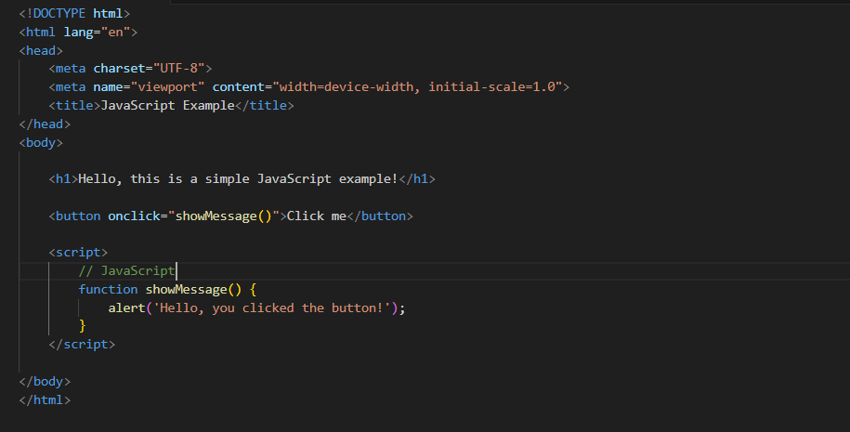

**Q.2 How many type of Variable in JavaScript?**

**Ans:-**

* There are three types of Variable in JS.

1. Var
2. Let
3. Const

**Examples:-**

1)var:-

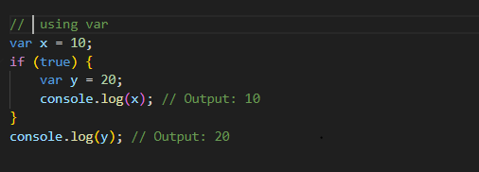

2)let

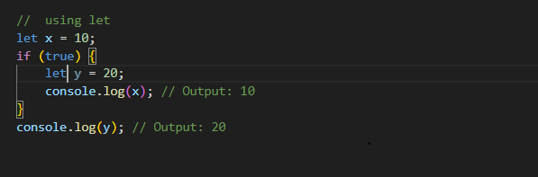

**Q.3 Define a Data Types in js?**

**Ans:-**

* There are Few types of data type

1. Number:- Numeric Value

**Example:-**

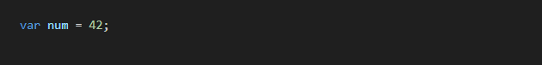

1. String:- Text Data

Example:-



1. Undefined:-Variable has been declared but not assign.

Example:-



1. Null:- Absence Value

Example:-



1. Boolean:- True or False

Example:-



1. Object:- Collection of key-value Pairs

Example:-

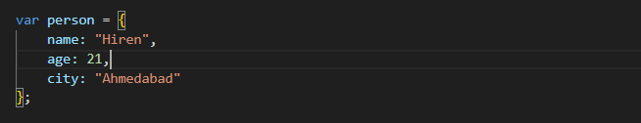

1. Array:- Orderd List of Value

Example:-

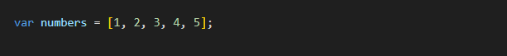

1. Function:- Block of Code…

Example:-

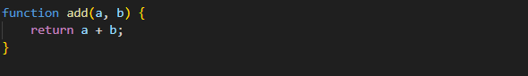

**Q.4 Write a mul Function Which will Work Properly When invoked With Following Syntax.**

**Ans:-**

* A function named ‘mul’ that can be invoked with a specific syntax.
* Assuming you want a function to multiply two numbers.
* **Example:-**

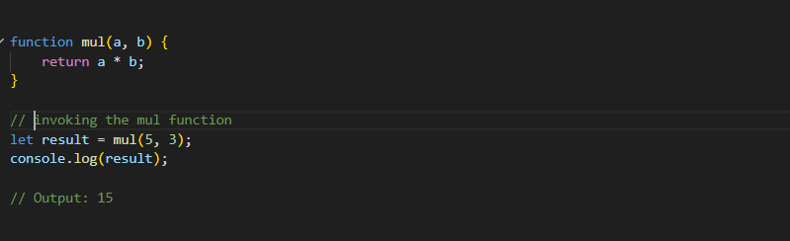

**Q.5 What the deference between undefined and undeclare in JavaScript?**

**Ans:-**

* Undefined:-
  + A variable is declared but has not been assigned a value, its type is undefined.
  + It can also be the default value of a function parameter if the argument is not provided.
  + If you try to access a variable that has been declared but not assigned a value, it will be undefined.
* **Example:-**

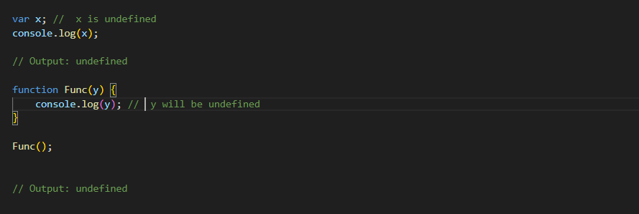

* Undeclare:-
  + A variable that has not been declared using var, let, or const, it is considered undeclared.
  + Accessing an undeclared variable will result in a ‘ReferenceError’.
* **Example:-**

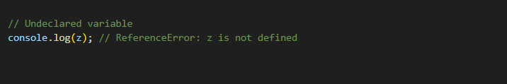

**Q.6 Using console.log() print out the following statement: The quote 'There is no exercise better for the heart than reaching down and lifting people up.' by John Holmes teaches us to help one another. Using console.log() print out the following quote by Mother Teresa:**

**Ans:-**

* **Example:-**

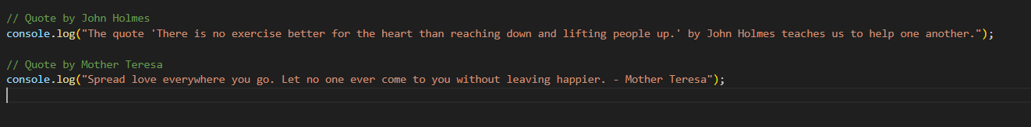

**Q.7 Check if typeof '10' is exactly equal to 10. If not make it exactly equal?**

**Ans:-**

* **Example:-**

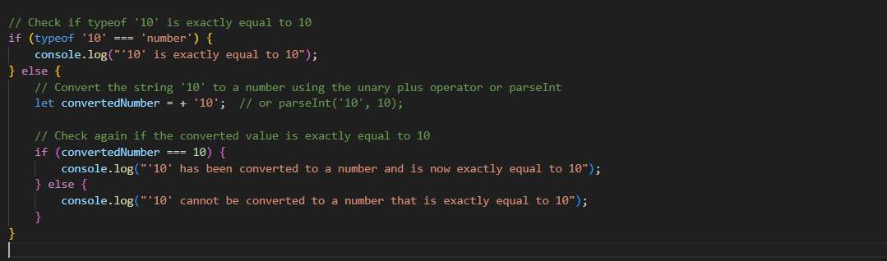

**Q.8 Write a JavaScript Program to find the area of a triangle?**

**Ans:-**

* **Example:-**

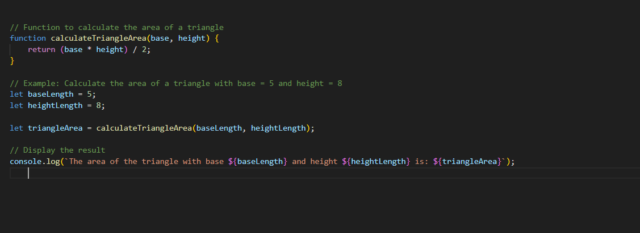

**Q.9 Write a JavaScript program to calculate days left until next Christmas?**

**Ans:-**

* **Example:-**

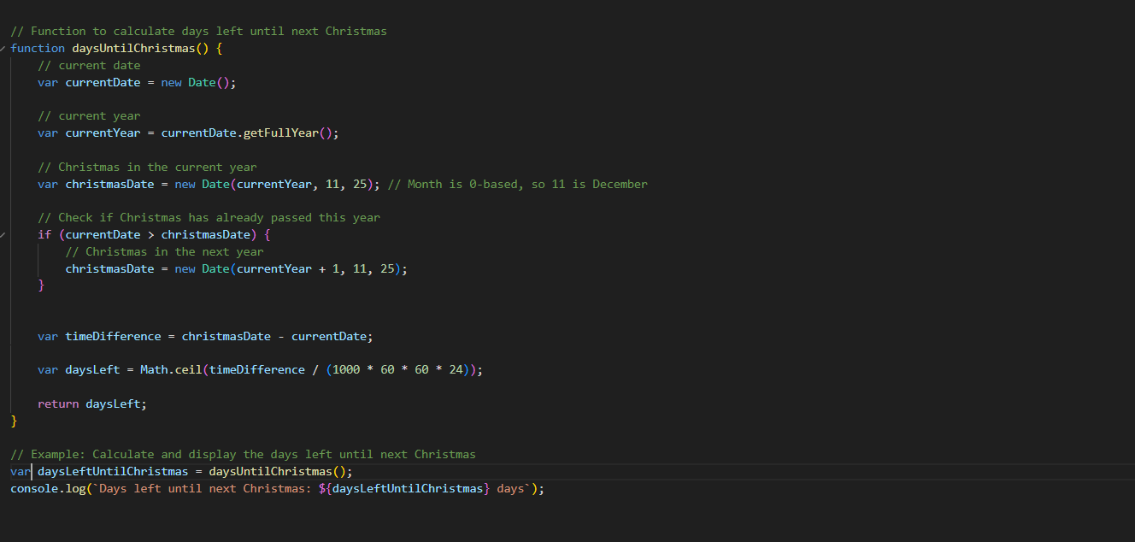

**Q.10 What is Condition Statement?**

**Ans:-**

* A conditional statement, also known as a "conditional," is a programming construct that allows you to execute different blocks of code based on whether a specified condition evaluates to true or false.
* Conditional statements are fundamental to control flow in programming and are used to make decisions in your code.
* **Example:-**

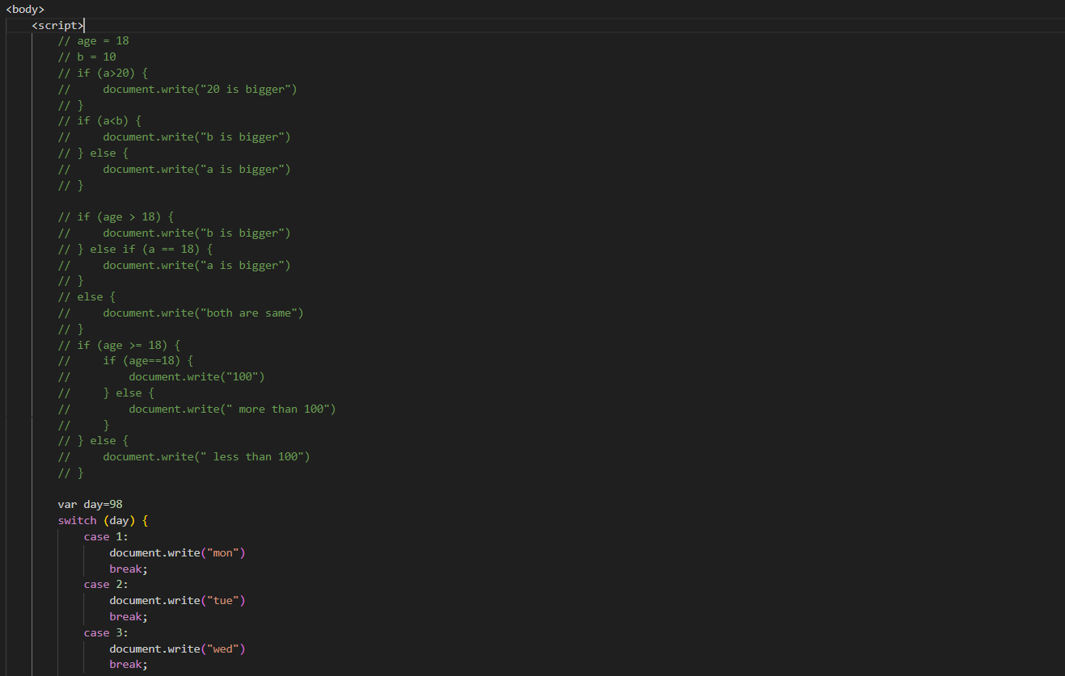

**Q.11 Find circumference of Rectangle formula : C = 4 * a ?**

**Ans:-**

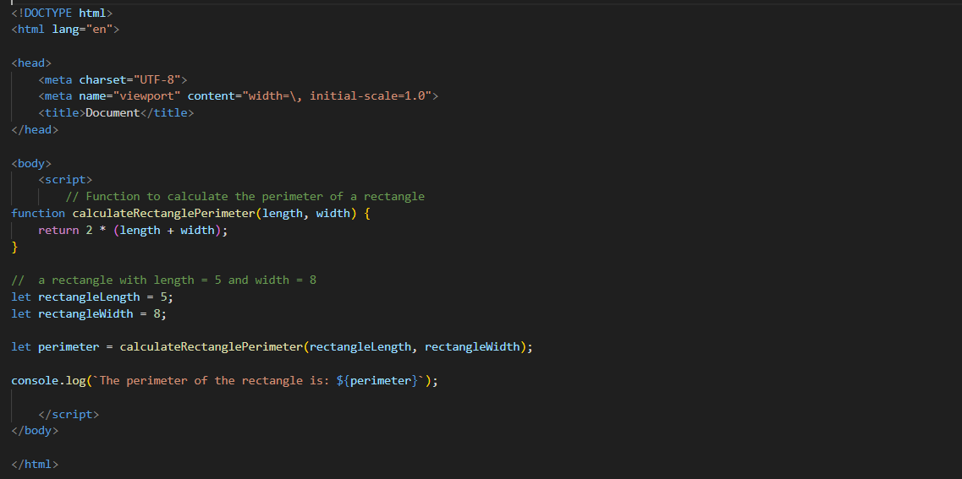

**Q.12 WAP to convert years into days and days into years?**

**Ans:-**

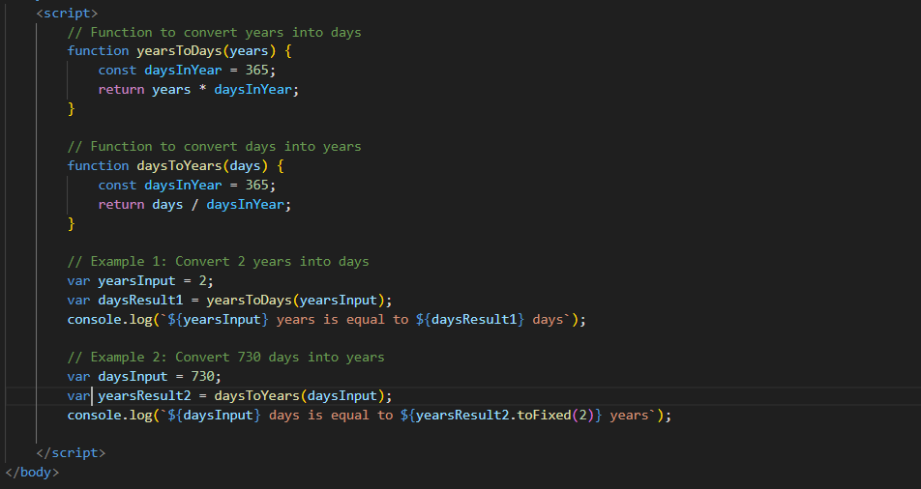

**Q.13 Convert temperature Fahrenheit to Celsius? (Conditional logic Question)**

**Ans:-**

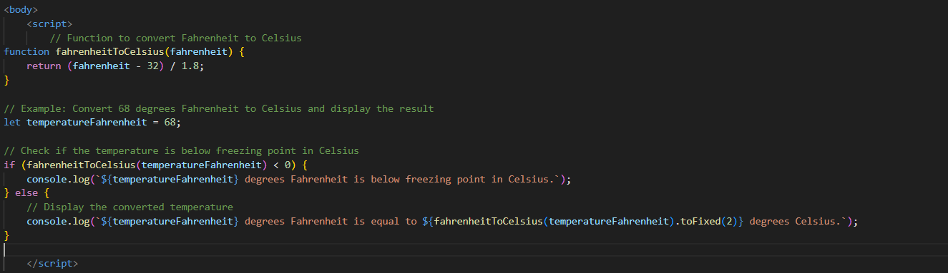

**Q.14 Write a JavaScript exercise to get the extension of a filename.?**

**Ans:-**

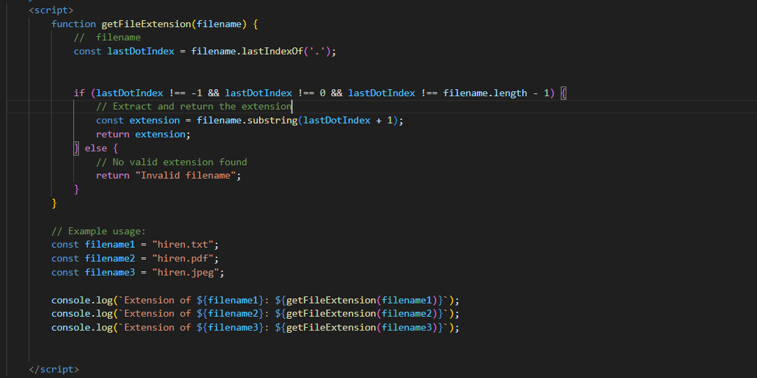

**Q.15 What is the result of the expression (5 > 3 && 2 < 4)?**

**Ans:-**

* The expression (5 > 3 && 2 < 4) is a logical AND (&&) operation.
* It evaluates to true if both conditions on either side of the && operator are true, and false otherwise.
* **Example:-**

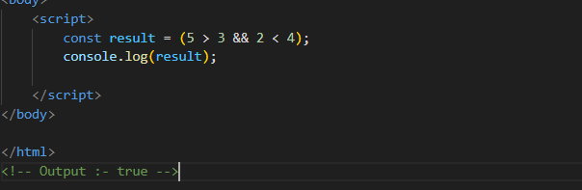

**Q.16 What is the result of the expression (true && 1 && "hello")?**

**Ans:-**

* The logical AND operator (&&) evaluates expressions from left to right and short-circuits if a false value is encountered.
* The result of the entire expression is the last evaluated operand.
* Example:-

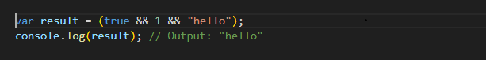

**Q.17 What is the result of the expression true && false || false && true?**

**Ans:-**

* The expression true && false || false && true involves the logical AND (&&) and logical OR (||) operators.
* The logical AND has higher precedence than logical OR, and the expression is evaluated from left to right.
* Example:-

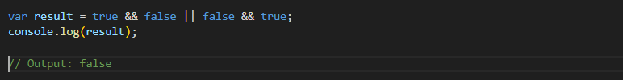

**Q.18 What is a Loop and Switch Case in JavaScript define that ?**

**Ans:-**

* Loop:-
* a loop is a control structure that allows you to repeatedly execute a block of code as long as a certain condition is true.
* There are three types of loop.

1)for :-The for loop is used when you know the number of iterations you want to perform.

**Example:-**

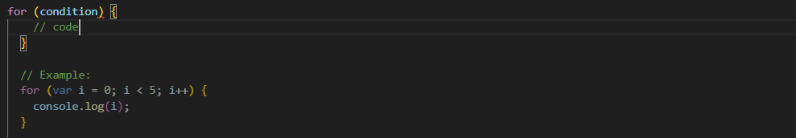

2)while :-The while loop is used when the number of iterations is not known beforehand, and the loop continues as long as a specified condition is true.

**Example:-**

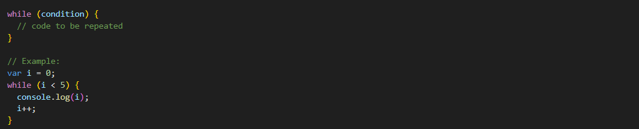

3)do while:- the while loop, the do-while loop executes the block of code at least once before checking the condition.

**Example:-**

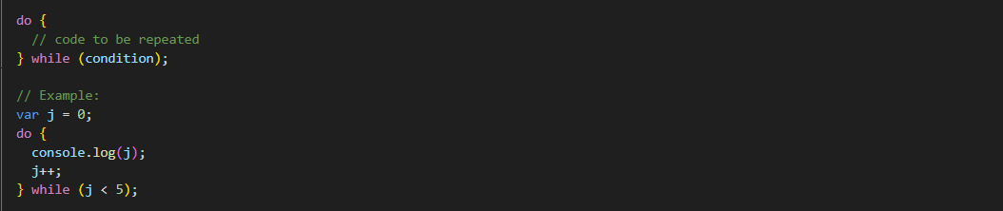

* Switch Case:-
  + A switch statement is used to perform different actions based on different conditions. It provides a more readable and concise way to write code that involves multiple if-else statements.

**Example:-**

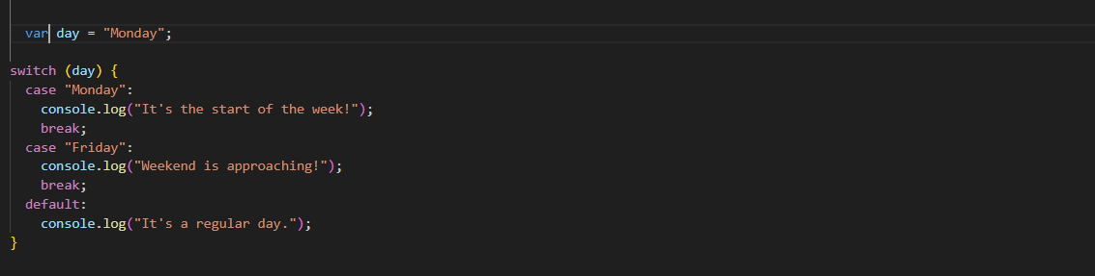

**Q.19 What is the use of is Nan function?**

**Ans:-**

* The NaN full form is " Not a Number."
* It is used to determine whether a value is NaN or can be converted to a number.
* The function returns a Boolean value, true if the value is NaN, and false if it is a valid number or can be converted to one
* **Example:-**

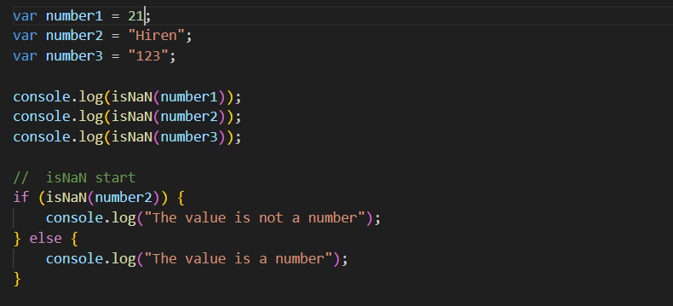

**Q.20 What is the difference between && and || in JavaScript?**

**Ans:-**

* &&:-
  + The && operator returns true if both operands are truthy; otherwise, it returns false.
  + It short-circuits, meaning if the left operand is falsy, it does not evaluate the right operand because the overall result will be false regardless.

**Example:-**

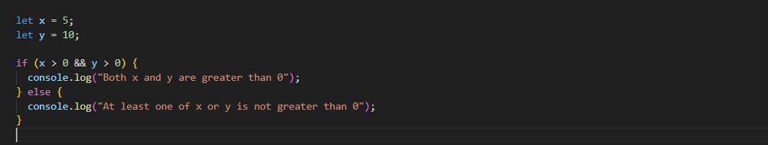

* ||:-
  + The || operator returns true if at least one of the operands is truthy; it returns false only if both operands are falsy.
  + Like &&, it short-circuits, meaning if the left operand is truthy, it does not evaluate the right operand because the overall result will be true regardless.

**Example:-**

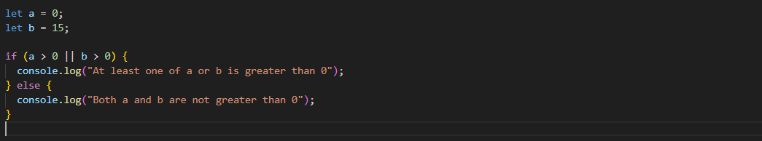

**Q.21 What is the use of Void (0)?**

**Ans:-**

* Void means return.
* **Example:-**

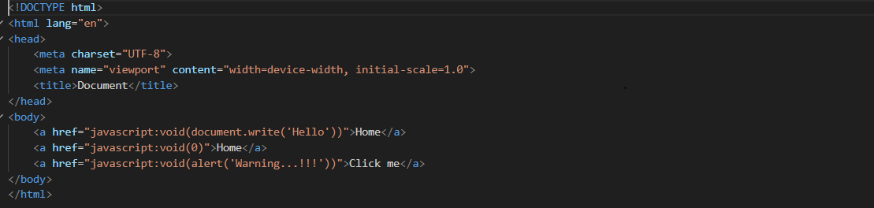

**Q.22 Check Number Is Positive or Negative in JavaScript?**

**Ans:-**

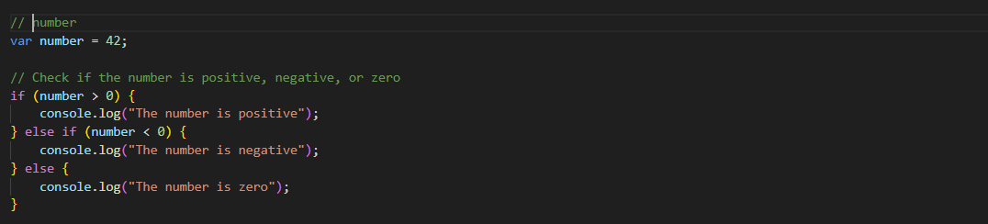

**Q.23 Find the Character Is Vowel or Not ?**

**Ans:-**

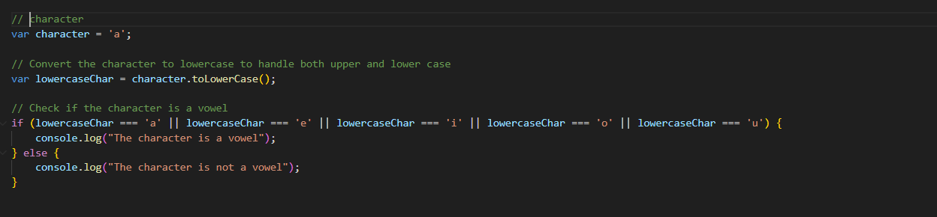

**Q.24 Write to check whether a number is negative, positive or zero?**

**Ans:-**



**Q.25 Write to find number is even or odd using ternary operator in JS?**

**Ans:-**

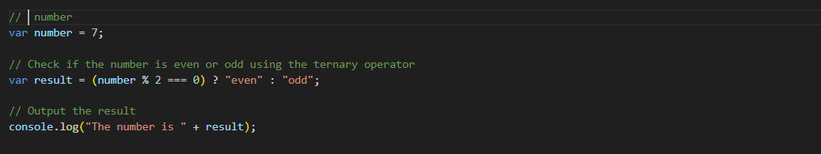

**Q.26 Write find maximum number among 3 numbers using ternary operator in JS?**

**Ans:-**

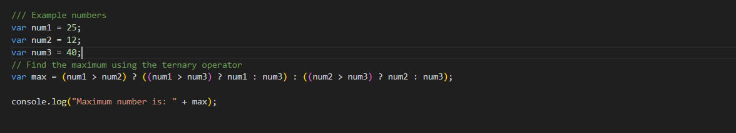

**Q.27 Write to find minimum number among 3 numbers using ternary operator in JS?**

**Ans:-**

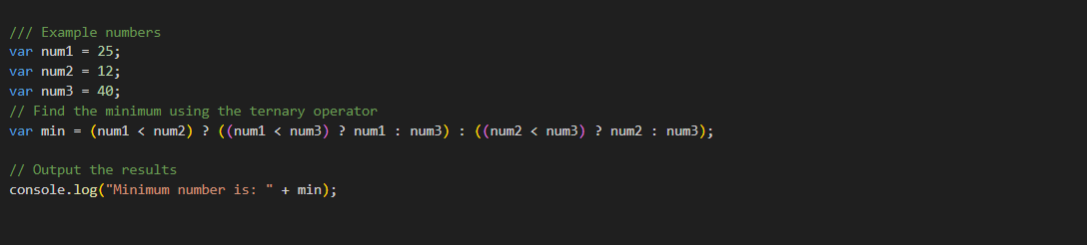

**Q.28 Write to find the largest of three numbers in JS?**

**Ans:-**

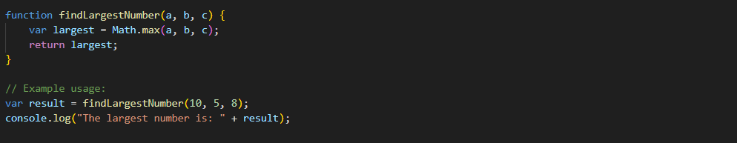

**Q.29 Write to show**

**i. Monday to Sunday using switch case in JS?**

**Ans:-**

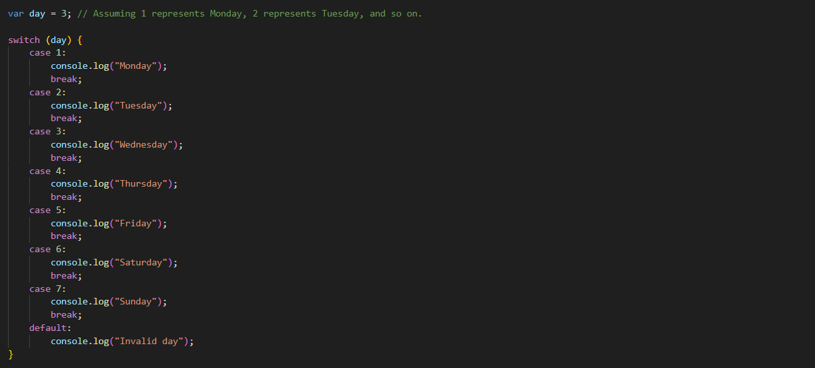

**ii. Vowel or Consonant using switch case in JS?**

**Ans:-**

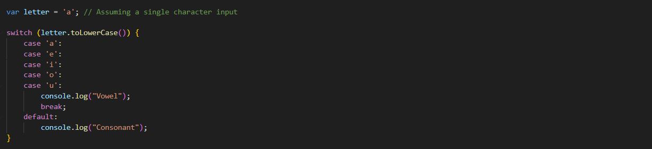

**(Conditional looping logic Question)**

**Q.30 What are the looping structures in JavaScript? Any one Example?**

**Ans:-**

* There are **Three** types of Loop.

1)for loop

2)while loop

3)do while loop

* **Example:-**

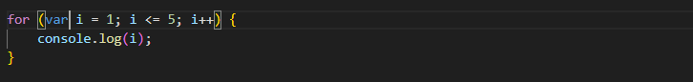

**Q.31 Write a print 972 to 897 using for loop in JS?**

**Ans:-**

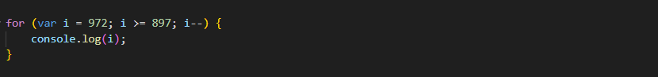

**Q.32 Write to print factorial of given number?**

**Ans:-**

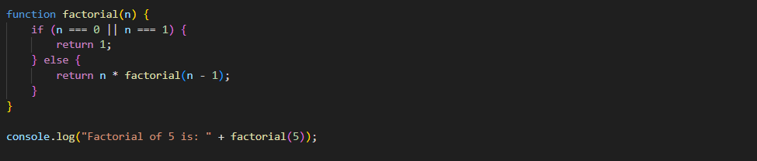

**Q.33 Write to print Fibonacci series up to given numbers?**

**Ans:-**

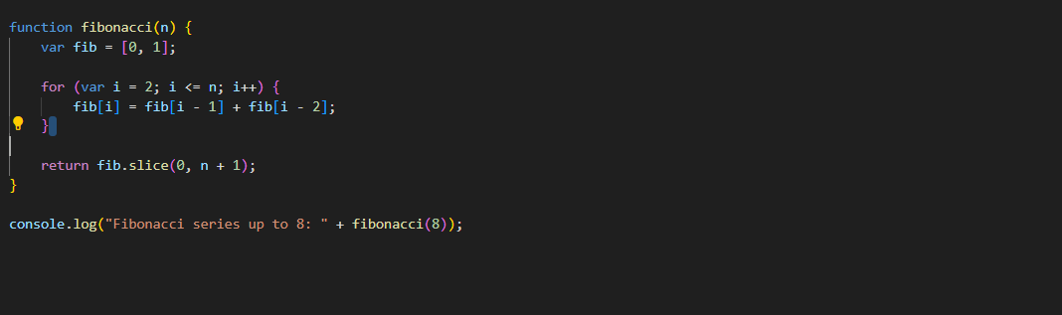

**Q.34 Write to print number in reverse order e.g.: number = 64728 ---> reverse =82746 in JS?**

**Ans:-**

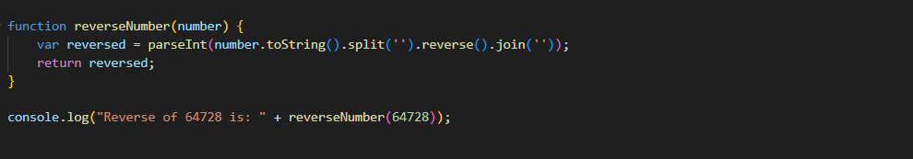

**Q.35 Write a program make a summation of given number (E.g., 1523 Ans: - 11) in JS?**

**Ans:-**

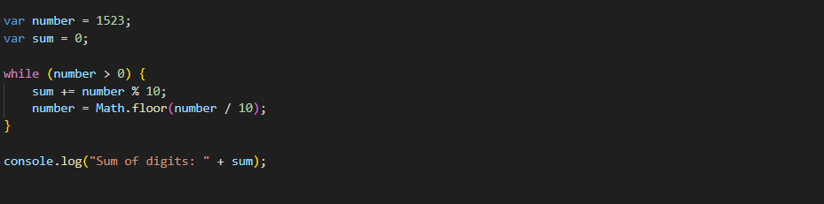

**Q.36 Write a program you have to make a summation of first and last Digit. (E.g., 1234 Ans: - 5) in JS?**

**Ans:-**

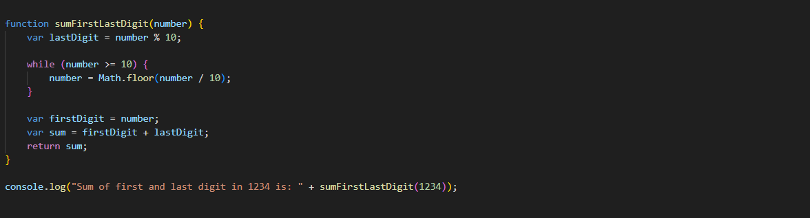

**Q.37 Use console.log() and escape characters to print the following pattern in JS?**

**1 1 1 1 1**

**2 1 2 4 8**

**3 1 3 9 27**

**4 1 4 16 64**

**5 1 5 25 125**

**Ans:-**

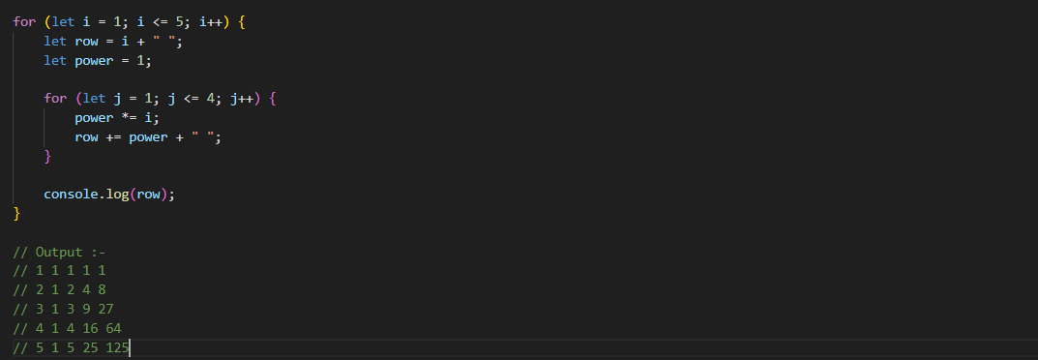

**Q.38 Use pattern in console.log in JS?**

**1) 1**

**1 0**

**1 0 1**

**1 0 1 0**

**1 0 1 0 1**

**Ans:-**

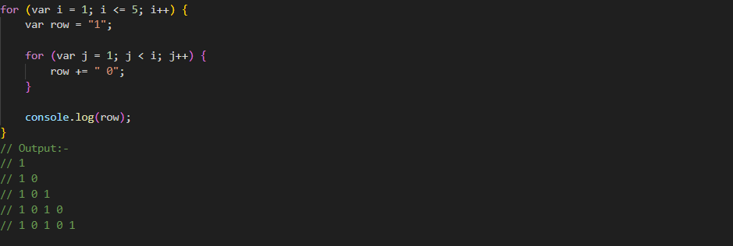

**2) A**

**B C**

**D E F**

**G H I J**

**K L M N O**

**Ans:-**

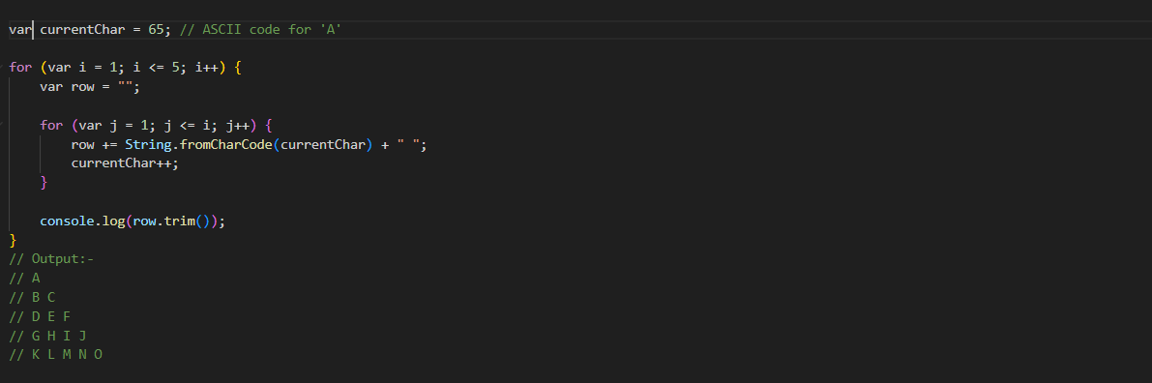

**3) 1**

**2 3**

**4 5 6**

**7 8 9 10**

**11 12 13 14 15**

**Ans:-**

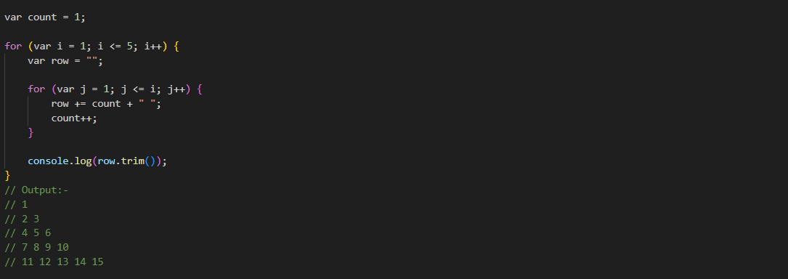

**4) \***

**\* \***

**\* * \***

**\* * * \***

**\* * * * \***

**Ans:-**

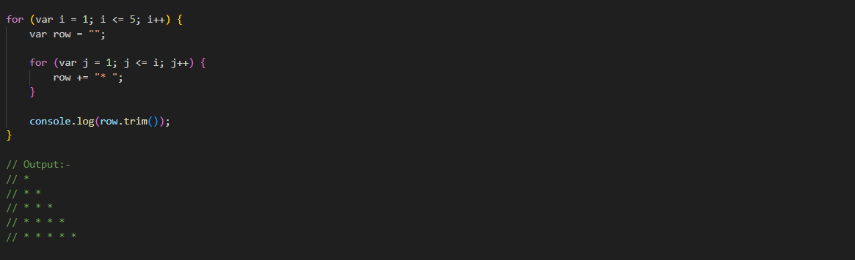

**Q.39 Accept 3 numbers from user using while loop and check each numbers palindrome?**

**Ans:-**

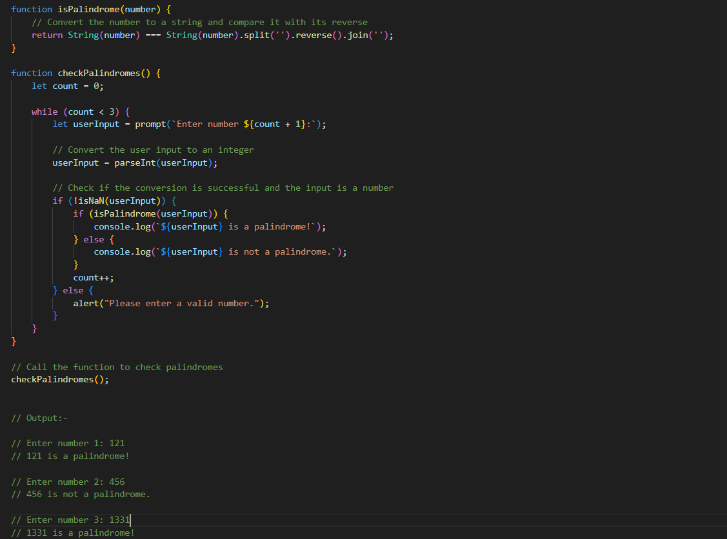

**(Array and object Question)**

**Q.40 Write a JavaScript Program to display the current day and time in the following format. Sample Output: Today is Friday. Current Time is 12 PM: 12 : 22 ?**

**Ans:-**

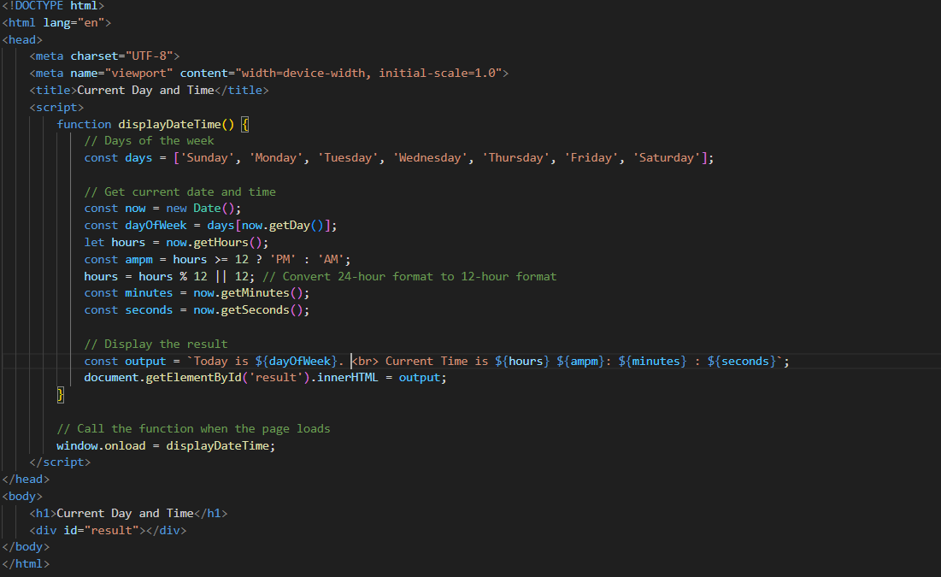

**Q.41 Write a JavaScript program to get the current date?**

**Ans:-**

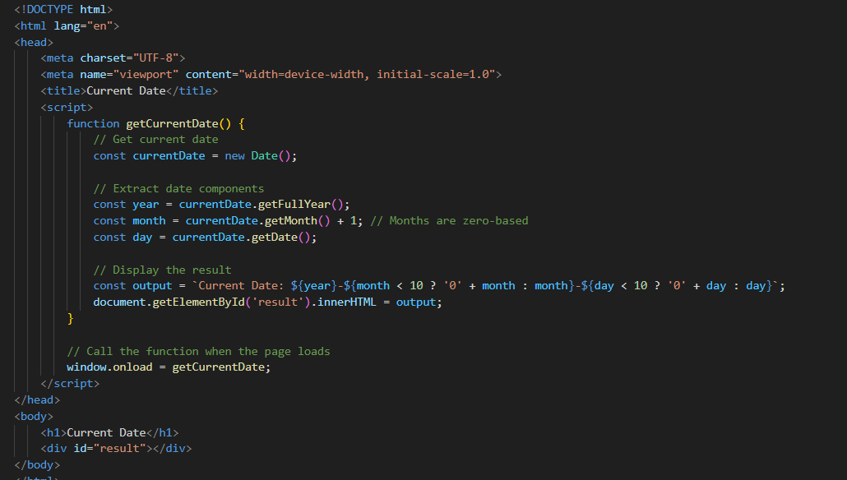

**Q.42 Write a JavaScript program to compare two objects?**

**Ans:-**

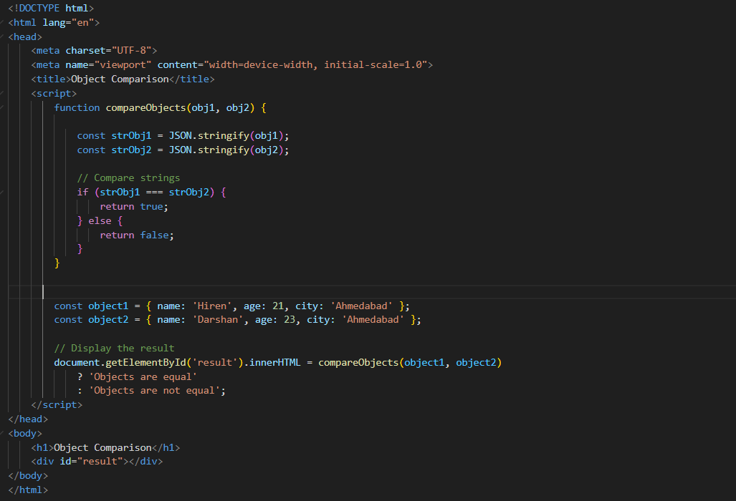

**Q.43 Write a JavaScript program to convert an array of objects into CSV string?**

**Ans:-**

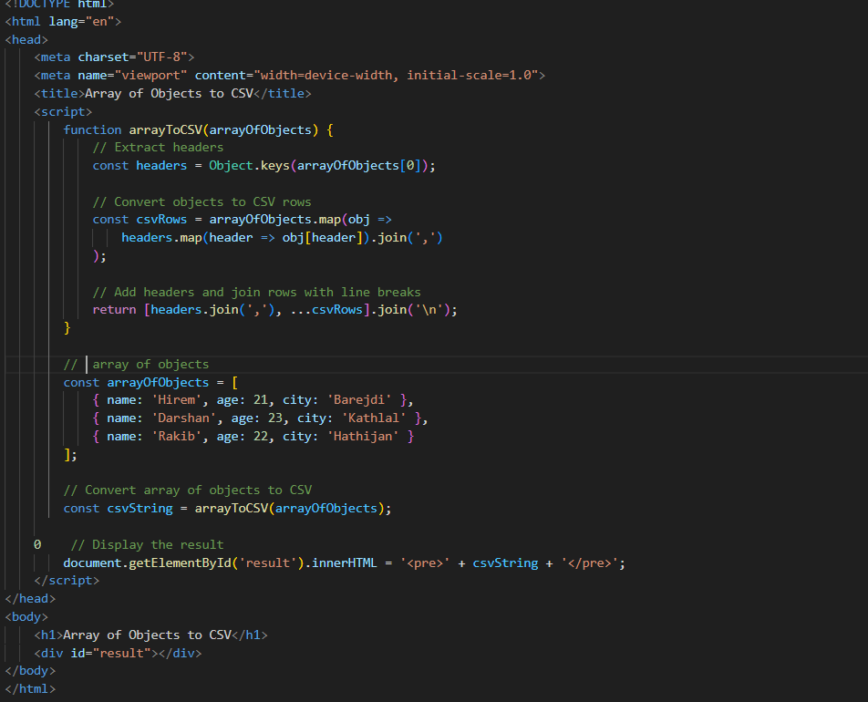

**Q.44 Write a JavaScript program to capitalize first letter of a string?**

**Ans:-**

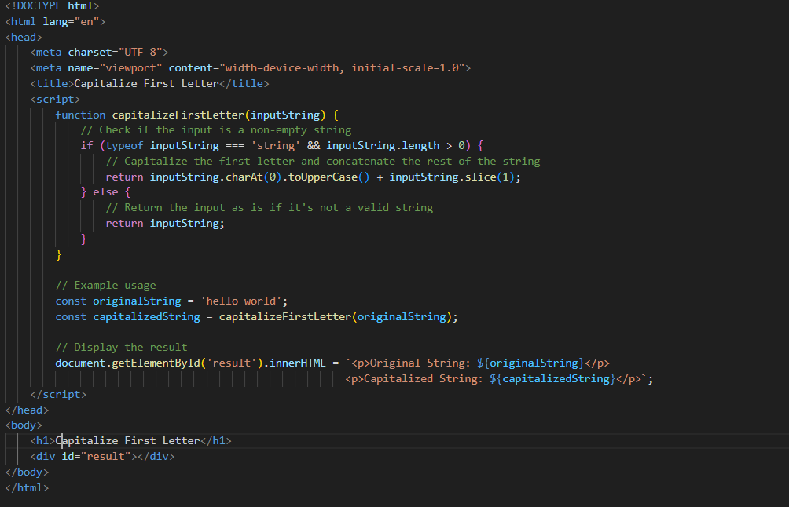

**Q. 45 Write a JavaScript program to determine if a variable is array?**

**Ans:-**

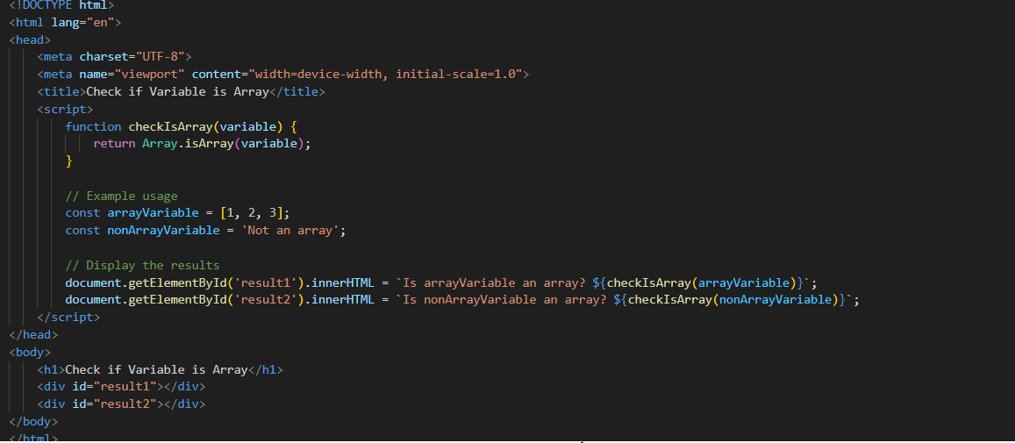

**Q.46 Write a JavaScript program to clone an array?**

**Ans:-**

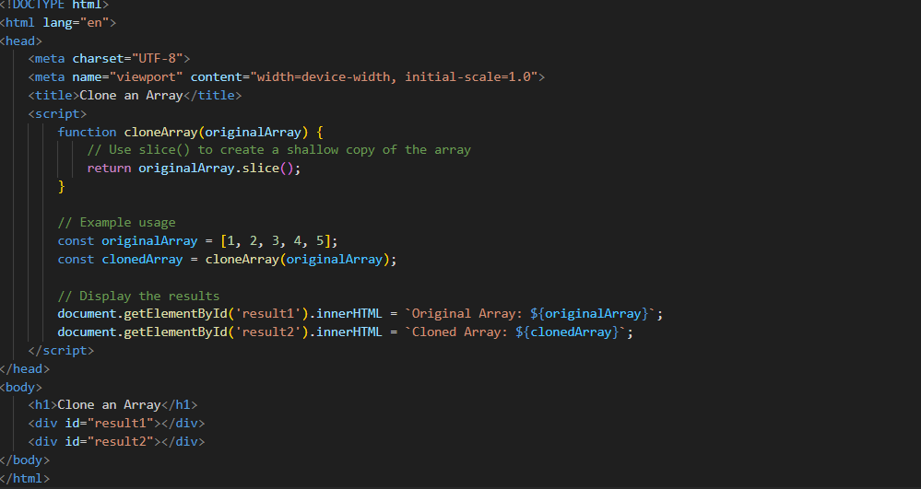

**Q.47 What is the drawback of declaring methods directly in JavaScript objects?**

**Ans:-**

* **Declaring Methods Directly in Methods**
* **Example:-**

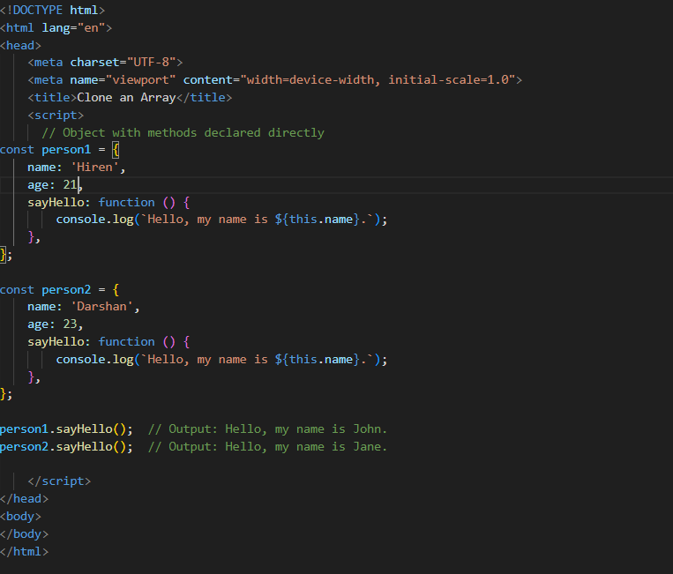

**Q.48 Print the length of the string on the browser console using console.log()?**

**Ans:-**

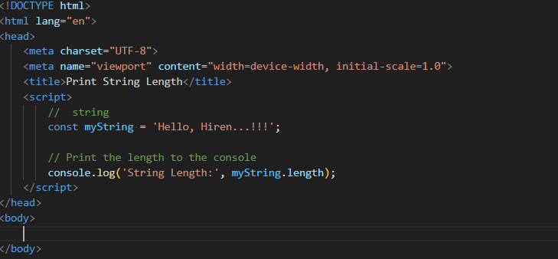

**Q.49 Change all the string characters to capital letters using toUpperCase() method?**

**Ans:-**

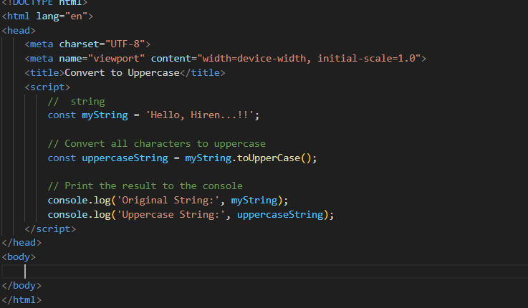

**Q.50 What is the drawback of declaring methods directly in JavaScript objects?**

**Ans:-**

* **Declaring Methods Directly in Methods:-**



**Q.51 Write a JavaScript program to get the current date. Expected Output : mm-dd-yyyy, mm/dd/yyyy or dd-mm-yyyy, dd/mm/yyyy?**

**Ans:-**

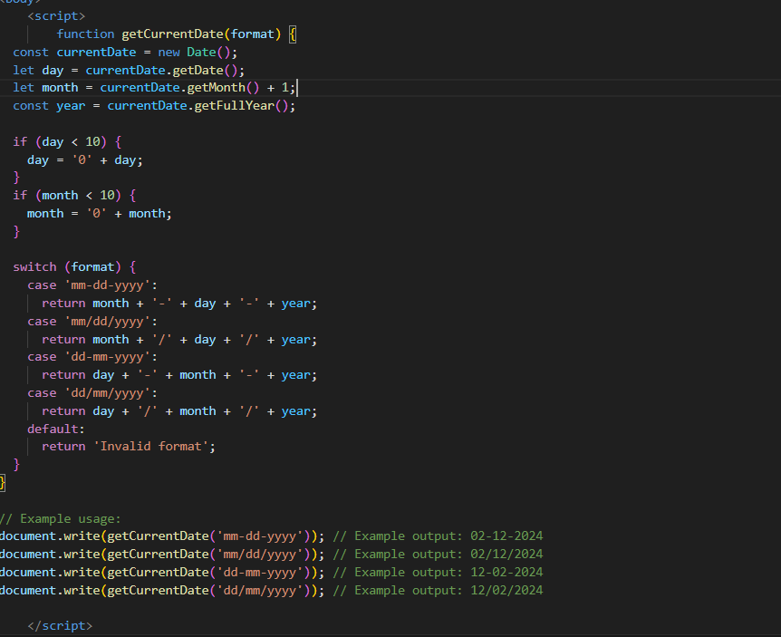

**Q.52 Use indexOf to determine the position of the first occurrence of a in 30 Days Of JavaScript?**

**Ans:-**

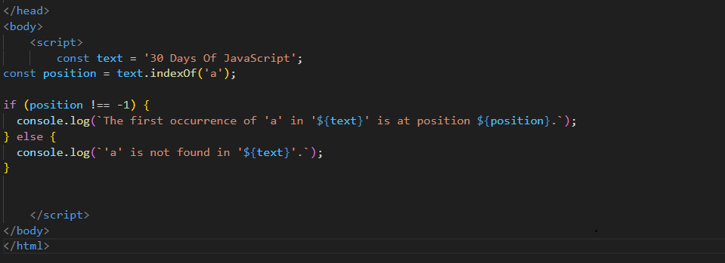

**Q.53 Use lastIndexOf to determine the position of the last occurrence of a in 30 Days Of JavaScript?**

**Ans:-**

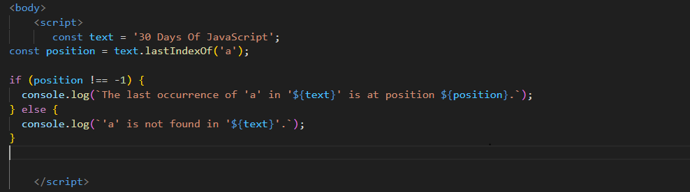

**Q.54 Form Validtion in JS?**

**Ans:-**

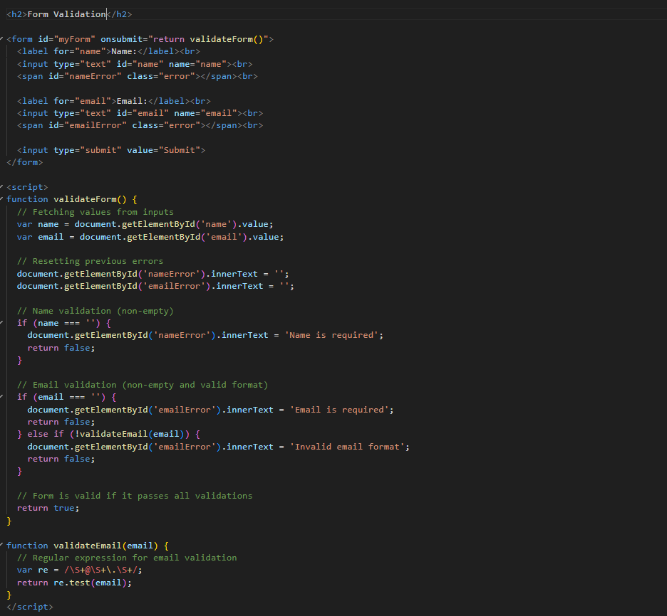

**Q.55 Form in Email, number, Password, Validation?**

**Ans:-**

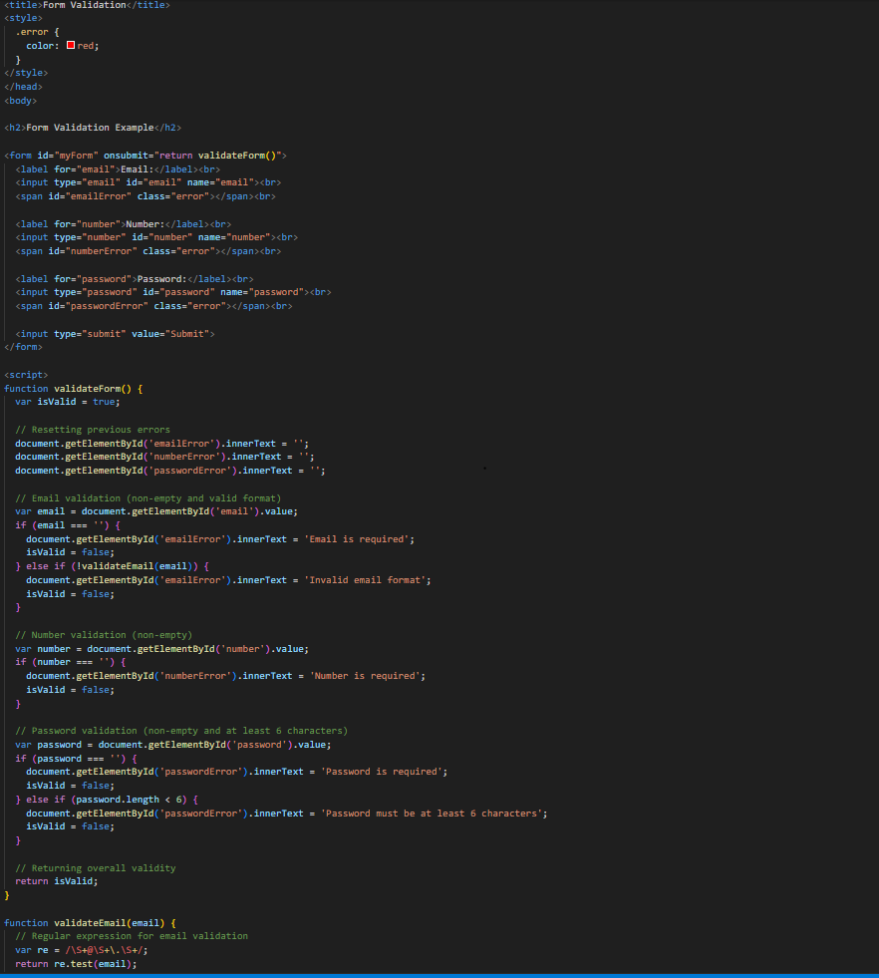

**Q.56 Dynamic Form Validation in JS?**

**Ans:-**

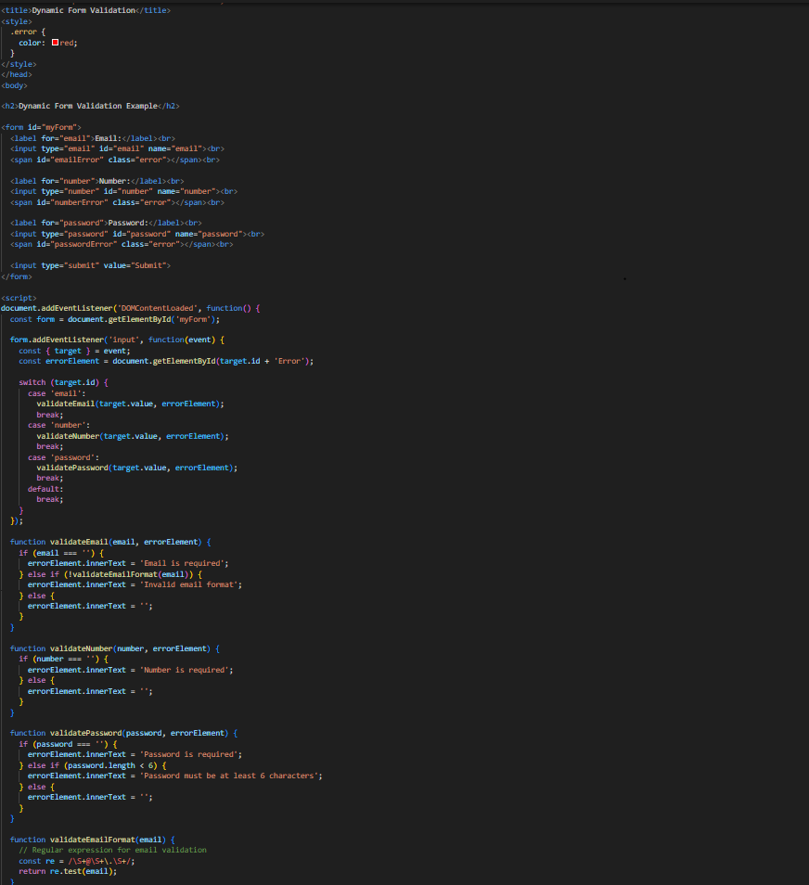

**Q.57 how many type of JS Event? How to use it ?**

**Ans:-**

* There are few types of Event in JS.

1. Mouse Event :- These events are triggered by user actions involving the mouse, such as clicking, hovering, or scrolling.
2. Keyboard Event:- Events that are triggered by keyboard interactions, such as pressing keys or releasing keys.
3. Form Event:- Events related to form elements, such as submitting a form, changing input values, or focusing on input fields.
4. Custom Event:- Events that can be defined and triggered by the user or the developer.

* To use these events, you can attach event listeners to DOM elements using methods like addEventListener
* **Example:-**

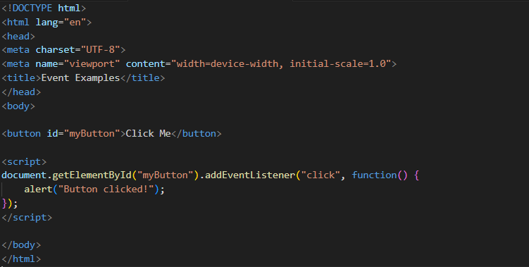

**Q.59 What is Bom vs Dom in JS?**

**Ans:-**

* **DOM (Document Object Model):** It represents the structure of HTML or XML documents as a tree-like model where each node represents an object in the document.

It allows scripts to dynamically access and modify the content, structure, and style of a document.

* **Example:-**

**console.log(document);**

* **BOM (Browser Object Model):** It provides objects and methods to interact with the browser window.

It includes objects such as window, document, location, history, navigator, etc.

The BOM is not standardized, and its features may vary between different browsers.

* **Example:-**

**console.log(window);**

**Q.60 Array vs object defences in JS?**

**Ans:-**

* **Array:-**
* Arrays are ordered collections of data.
* Elements in arrays are accessed by their index.
* Arrays are ideal for storing lists of similar items or ordered data.
* **Example:-**

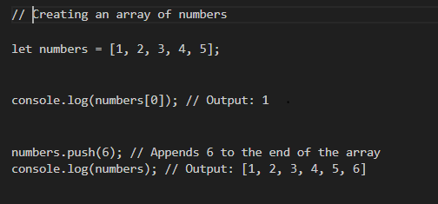

* **Object:-**
* Objects are collections of key-value pairs, where keys are strings (or symbols) and values can be of any data type.
* Objects are unordered, meaning there is no guarantee of the order in which properties are stored.
* They areideal for representing structured data or mapping properties to values**.**
* **Example:-**

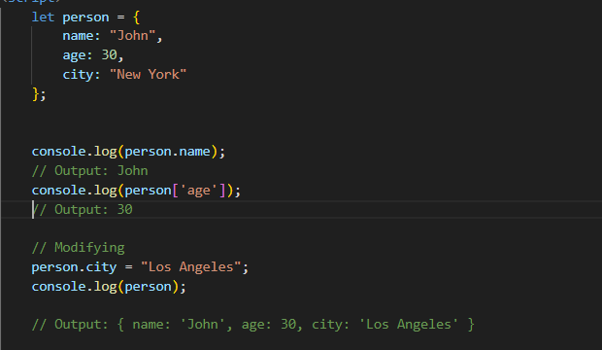

**Q.61 Split the string into an array using split() Method?**

**Ans:-** 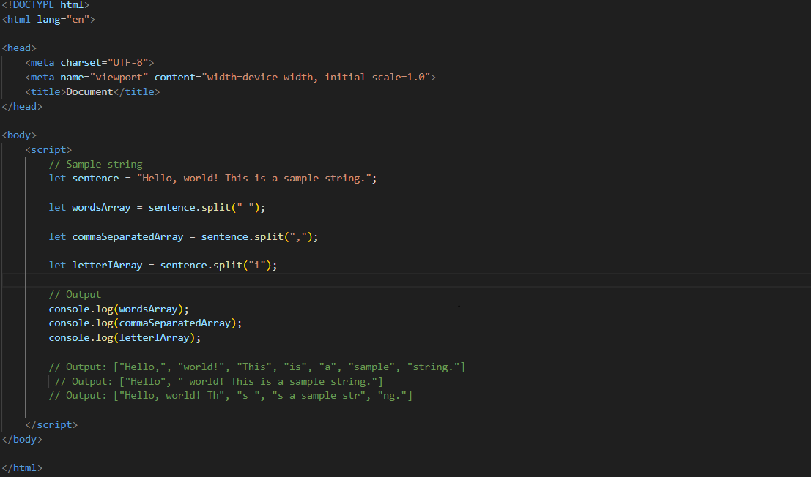

**Q.62 Check if the string contains a word Script using includes() method?**

**Ans:-**

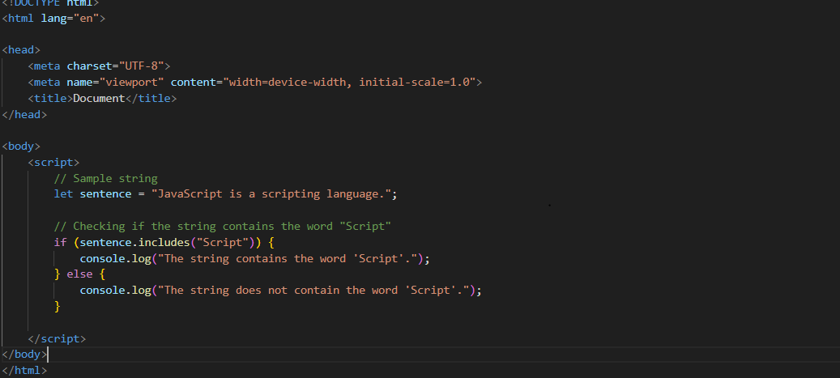

**Q.63 Change all the string characters to lowercase letters using toLowerCase() Method.**

**Ans:-**

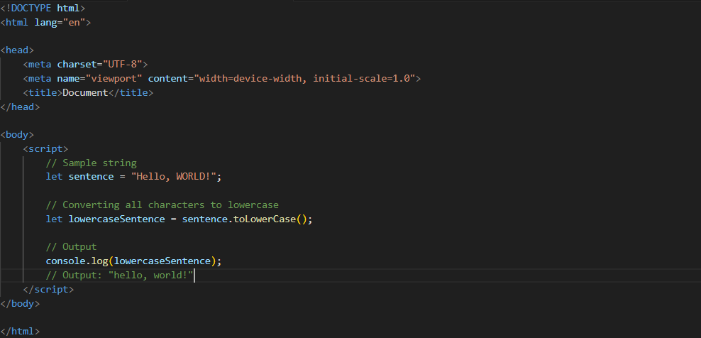

**Q.64 What is Character at index 15 in ’30 Days of JavaScript’ string? Use charAt() method.**

**Ans:-**

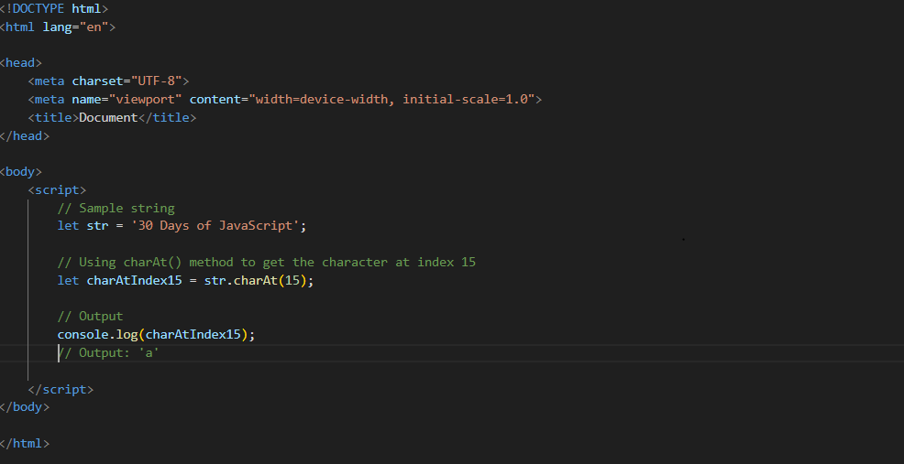

**Q.65 copy to one string to another string in JS?**

**Ans:-**

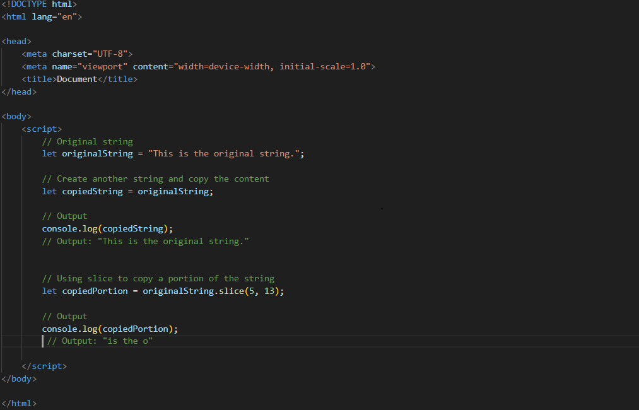

**Q.66 Find the length of a string without using libraryFunction?**

**Ans:-**

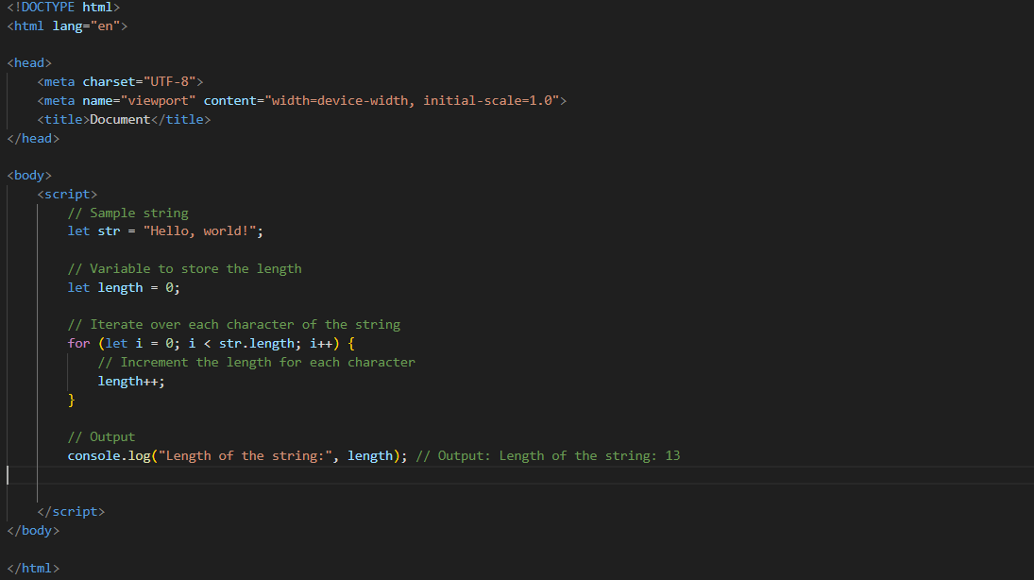

**Q.1) What is JavaScript?**

**Ans:-**

* JavaScript is a high-level, interpreted programming language primarily used for creating interactive and dynamic content on websites.
* It allows you to manipulate the content, structure, and behavior of a web page.
* JavaScript is used in conjunction with HTML and CSS to enhance the user experience.
* **Example:-**

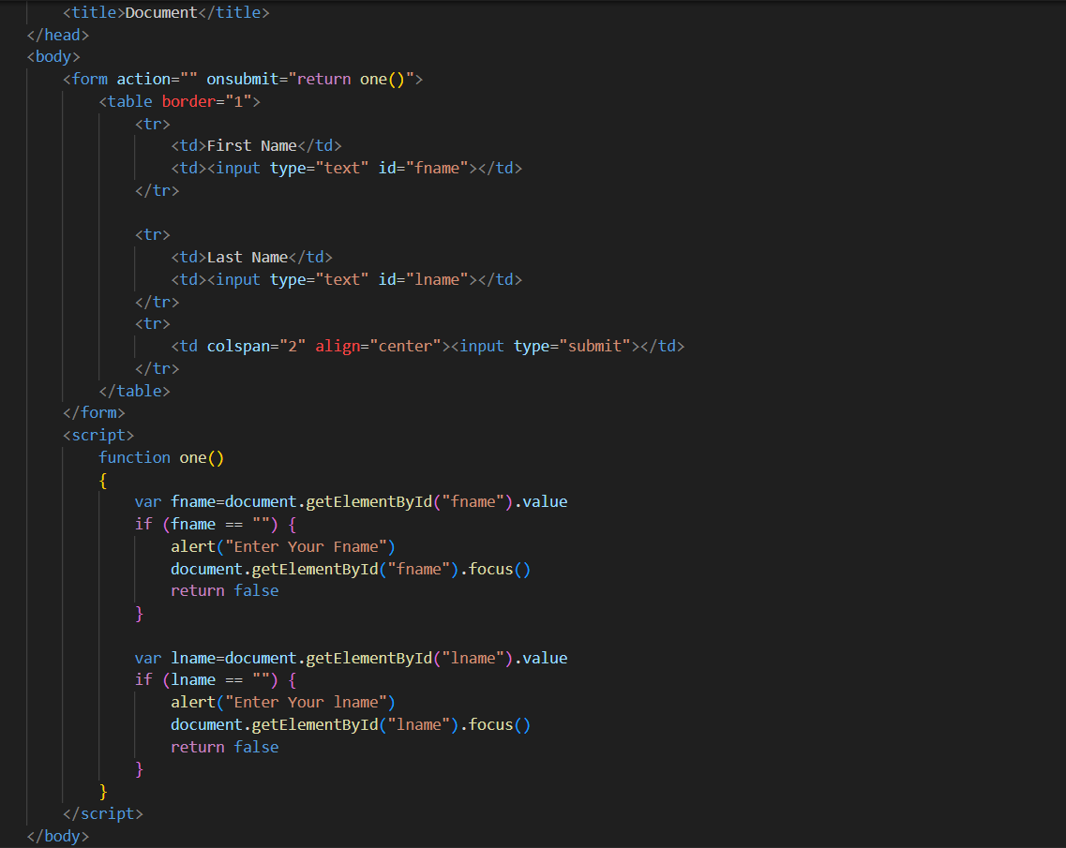

**Q.2) What is the use of is NaN function?**

**Ans:-**

* The NaN full form is " Not a Number."
* It is used to determine whether a value is NaN or can be converted to a number.
* The function returns a Boolean value, true if the value is NaN, and false if it is a valid number or can be converted to one
* **Example:-**



**Q.3) What is negative Infinity?**

**Ans**:-

* Infinity is a special numeric value representing positive infinity.
* there is called -Infinity.
* which represents negative infinity.
* **Example:-**

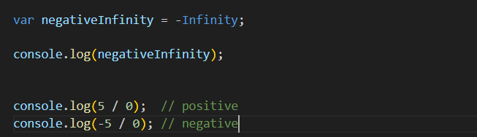

**Q.4) Which company developed JavaScript?**

**Ans:-**

* JavaScript developed by Netscape Communications Corporation.
* The development was led by Brendan Eich, and the language was introduced in Netscape Navigator browser in 1995.
* It was original name "Mocha" and later "LiveScript" before settling on the name JavaScript.

**Q.5) What are undeclared and undefined variables?**

**Ans:-**

* **Undeclared Variable:-**
  + Undeclared variable is used in code without declared using the var, let, or const keyword.
  + Undeclared variable can lead to unexpected behavior and is generally considered a coding mistake.
* **Undefined Variable :-**
  + Undefined variable is a variable that has been declared but not assigned a value.
  + A variable is declared but not initialized, it automatically gets the value undefined.

**Q.6) Write the code for adding new elements dynamically?**

**Ans:-**

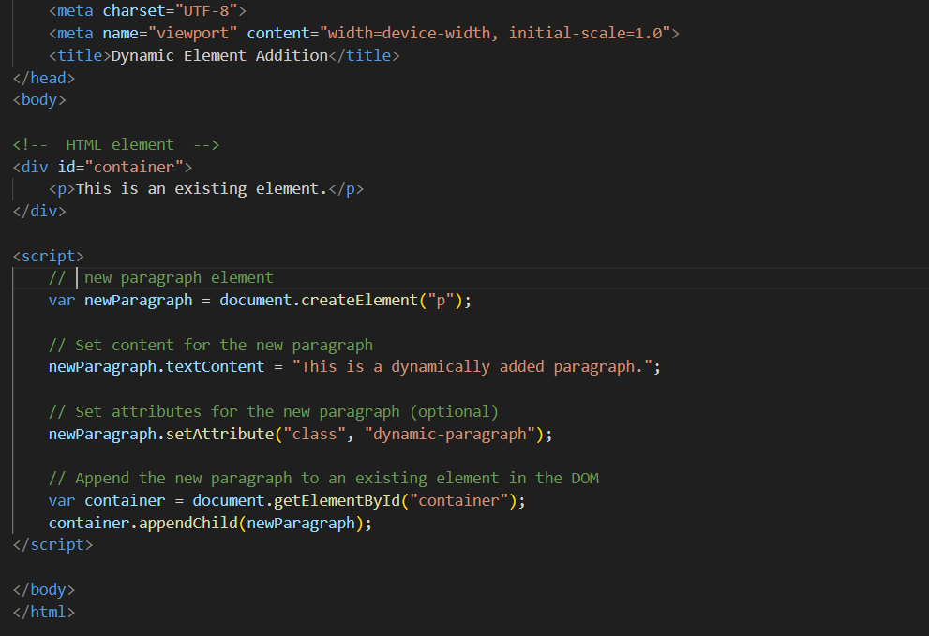

**Q.7) What is the difference between View State and Session State?**

**Ans:-**

* **View State:**
  + - View State is used to persist the state of a single web page across postbacks.
    - It's a client-side state management technique, and the data is stored in a hidden field on the web page.
* **Session State:**
  + Session State is used to persist data across multiple requests and pages for a particular user session.
  + It's a server-side state management technique, and the data is stored on the server.

**Q.8) What is === operator?**

**Ans:-**

* the === operator is a strict equality operator.
* It checks whether its two operands are equal, both in value and in data type.
* If the operands are of the same type and have the same value, === returns true; otherwise, it returns false.
* **Example:-**

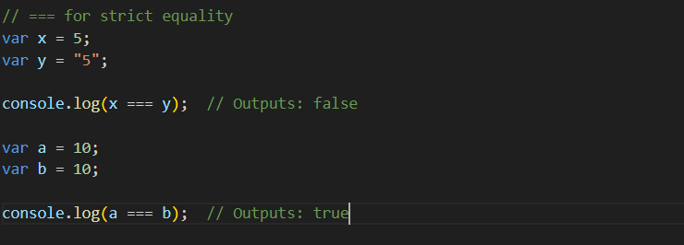

**Q.9) How can the style/class of an element be changed?**

**Ans:-**

1. Changing Style with Java Script:-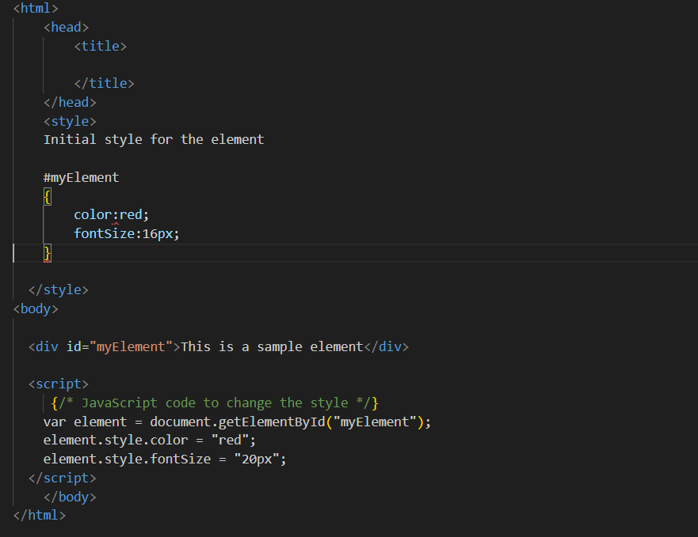
2. Changing Class with JavaScript:-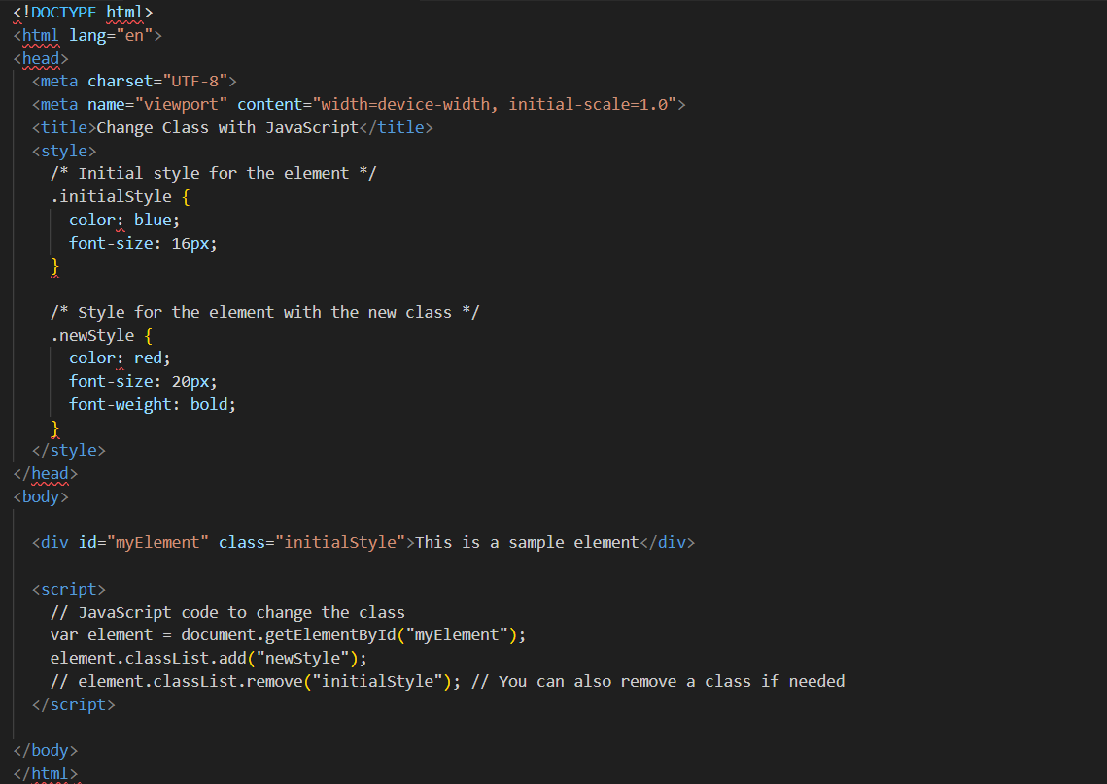

**Q.10) How to read and write a file using JavaScript?**

**Ans:-**

* **Read a File:-**

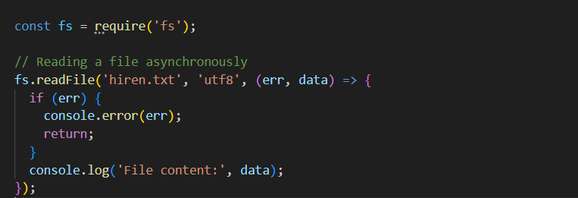

* **Writing a File:-**

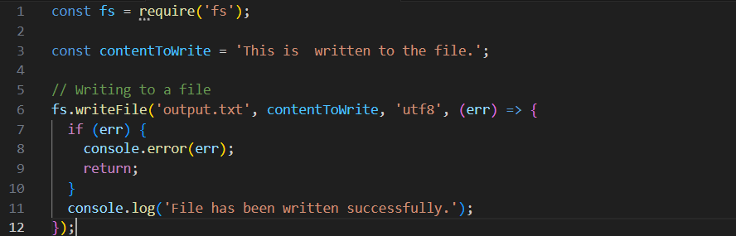

**Q.11)What are all the looping structures in JavaScript?**

**Ans:-**

1. **For loop:-**

**Ex.** for (let i = 0; i < 5; i++)

{

console.log(i);

}

**// Output: 0, 1, 2, 3, 4**

1. **While loop:-**

**Ex.** let i = 0;

while (i < 5)

{

console.log(i);

i++;

}

**// Output: 0, 1, 2, 3, 4**

1. **Do while loop:-**

**Ex.** let i = 0;

Do

{

console.log(i);

i++;

}

while (i < 5);

**// Output: 0, 1, 2, 3, 4**

**Q.12) How can you convert the string of any base to an integer in JavaScript?**

**Ans:-**

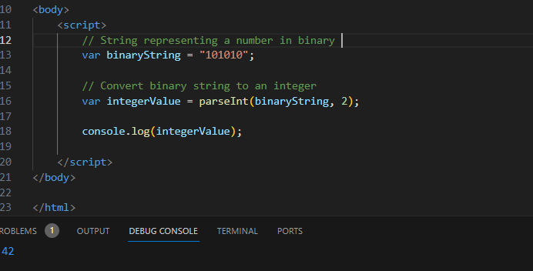

**Q.13)What is the function of the delete operator?**

**Ans:-**

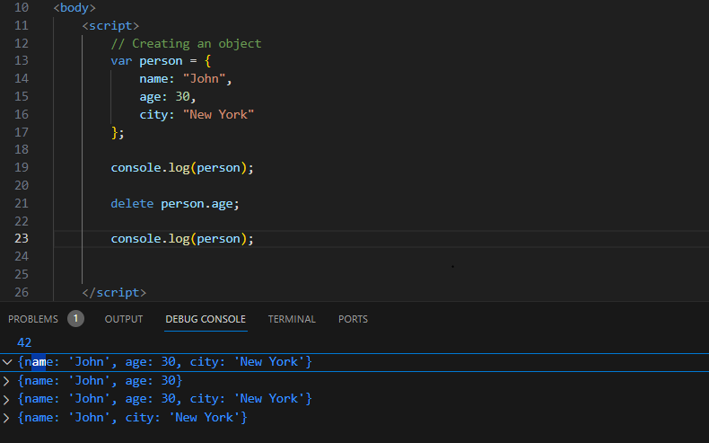

**Q.14)What are all the types of Pop up boxes available in JavaScript?**

**Ans:-**

1. **Alert box:-** Displays a message to the user with an "OK" button to acknowledge the message.

**Example:-**

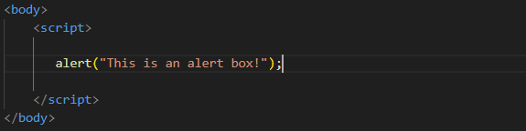

1. **Confirm box:-** Displays a message to the user with "OK" and "Cancel" buttons, allowing the user to confirm or cancel an action.

**Example:-**

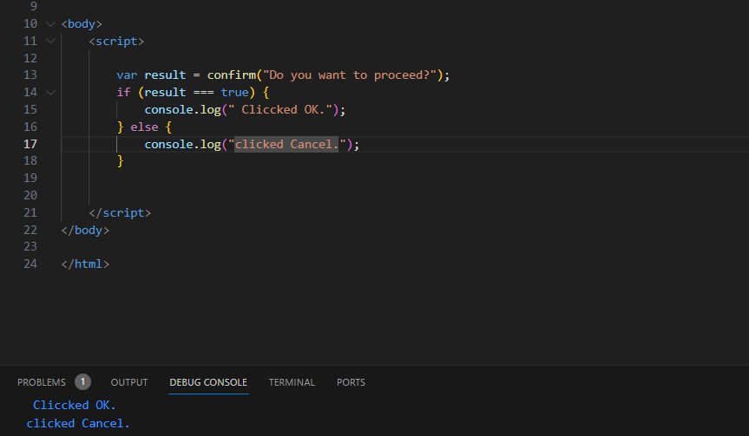

1. **Prompt box:-** Displays a message to the user with an input field for the user to enter data. It returns the text entered by the user when they click "OK", or null if they click "Cancel".

**Example:-**

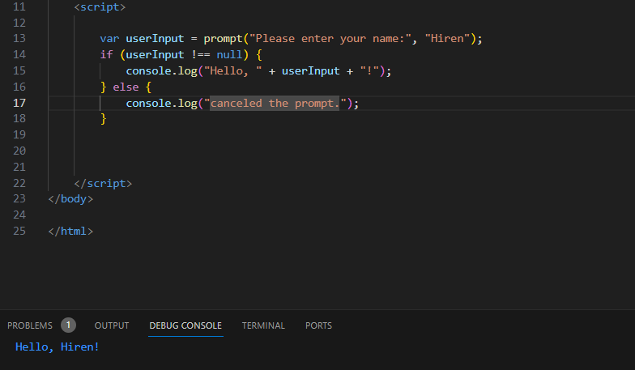

**Q.15) What is the use of Void (0)?**

**Ans:-**

* Void means return.
* **Example:-**



**Q.16) How can a page be forced to load another page in JavaScript?**

**Ans:-**

* Js can force a page to load another page using the window.location object. There are a few different ways to this:
* window.location.href = "www.hiren.com";
* window.location.replace("www.hiren.com");
* window.location.assign("www.hiren.com");